**SCHOOL MANAGEMENT SYSTEM**

#### PROJECT REPORT

**Submitted in partial fulfillment of the requirements for the award Degree of**

**BACHELOR OF COMPUTER APPLICATIONS**

**Of the University of Calicut**

#### Submitted By

**RASHIN KP (NZAVBCA018)**

**MUHAMMED NUHMAN CK (NZAVBCA014)**

**MUHAMMED ASHIN P (NZAVBCAO13)**

**Guided By**

**Mrs. RUMAISA**



**DEPARTMENT OF COMPUTER SCIENCE**

**NASRA COLLEGE OF ARTS & SCIENCE**

**THIRURKAD -679325**

**2023– 2024**

**DEPARTMENT OF COMPUTER SCIENCE**

**NASRA COLLEGE OF ARTS & SCIENCE**

#### (Affiliated to university of Calicut)

**TIRURKAD - 679325**

PROJECT WORK

**CERTIFICATE**

Certified that this is a bonafied record of the project work

**SCHOOL MANAGEMENT SYSTEM**

Done by

**RASHIN KP (NZAVBCA018)**

**MUHAMMED NUHMAN CK (NZAVBCA014)**

**MUHAMMED ASHIN P (NZAVBCA013)**

Submitted in partial fulfilment of the requirements for the award of the

Degree Bachelor of Computer Application of the University of Calicut

Faculty Guide Head of the Department

External Examiner

**DEPARTMENT OF COMPUTER SCIENCE**

**NASRA COLLEGE OF ARTS & SCIENCE**

TIRURKAD, MALAPPURAM – 679325



**CERTIFICATE**

This is to certify that this Project report entitled "School Management System" is a bonafied record of the project done by, RASHIN KP, MUHAMMED ASHIN P, MUHAMMED NUHMAN CK of sixth semester BCA, Nasra College Of Arts And Science, Tirurkad, towards partial fulfilment of the requirement for the award of degree of Bachelor of Computer Applications University of Calicut

**Internal Guide Head of Department**

**Rumaisa Nabeela (HOD)**

Department of Computer Science Department of Computer Science

Nasra College Arts&Science, Thirurkkad Nasra College Arts&Science, Thirurkkad

**Submitted for Viva-Voice Examination held on …………………**

**INTERNAL EXAMINER EXTERNAL EXAMINAR**

**Name: Name:**

**Signature: Signature:**

**Date: Date:**

**DECLARATION**

I hereby that this project work entitled ' School Management System' submitted at Nasra College of Arts & Science (Affiliated to University of Calicut) is a record of original work done us under the supervision and guidance of Mrs. Rumaisa Department of Computer Science.

**RASHIN KP(NZAVBCA018)**

**MUHAMMED NUHMAN CK (NZAVBCA014)**

**MUHAMMED ASHIN P(NZAVBAC013)**

Signature of Candidate

**RASHIN KP:**

**MUHAMMED NUHMAN CK:**

**MUHAMMED ASHIN P:**

**ACKNOWLEDGEMENT**

First of all, we would like to express our sincere gratitude to God Almighty for the constant love and grace he has showered upon us. We express our gratitude to the respected principal Dr. P. Zubair, Nasra College of Arts & Science Tirurkad, for us this golden opportunity to undertake our course in this college. We also express our great deal of gratitude to the Head of Department and our internal guide, Mrs. Rumaisa for her effective guidance, timely suggestions, and encouragement. We also express our gratitude to all teachers in Department of Computer Science.

**SYNOPSIS**

The School Management System (SMS) offers a transformative solution for modern educational institutions. With its user-friendly interface and comprehensive features, SMS optimizes school operations, fosters transparency, and empowers all stakeholders within the educational ecosystem. Through seamless integration of frontend technologies like HTML, CSS, and JavaScript, coupled with a robust backend powered by Node.js, Express.js, and MongoDB, SMS ensures efficient data management, secure user authentication, and role-based access control. From admissions management to attendance tracking, grade storage, and event scheduling, SMS revolutionizes administrative tasks, enhancing communication, collaboration, and engagement among students, teachers, parents, and administrators.

Furthermore, SMS lays the foundation for future enhancements, including integration with online payment gateways, development of a mobile application for on-the-go access, implementation of advanced reporting and analytics tools, and incorporation of e-learning features. By continually evolving to meet the evolving needs of educational institutions, SMS remains at the forefront of innovation, driving efficiency, effectiveness, and empowerment in education.

**CONTENTS**

**1: INTRODUCTION8**

1.1 Introduction9

1.2 Objectives10

1.3 Project Overview13

1.4 Organizational Profile14

1.5 Existing System18

1.6 Proposed System21

1.7 Feasibility Study23

**2: SYSTEM REQUIRMENT SPECIFICATION** **26**

2.1Sofware Requirements27

2.1.1 For Admin27

2.1.1 For User28

2.2 Hardware Requirements 28

**3: SOFTWARE IMPLEMENTATION 32**

3.1 Front-End33

3.2 Back-End37

3.3 Database 38

3.4 IDE39

3.5 System Architecture 40

**4: DESIGN AND PLANNING42**

4.1 SDLC43

4.2 DFD 46

**5: PROGRAM CODE AND RESULTS50**

**6: TESTING 73**

6.1 Testing74

**7: Development Challenges77**

**8: Limitations of The Project:79**

**9: Future Enhancement82**

**10: Conclusion84**

**11: Bibliography 86**

**INTRODUCTION**

**1.1 INTRODUCTION**

In the digital age, the effective management of educational institutions has become increasingly complex, necessitating the integration of technological solutions to streamline administrative processes. Our project, the School Management System, addresses this need by offering a comprehensive platform designed to enhance the efficiency and efficacy of school operations. This report encapsulates the development and implementation of our School Management System, which is built on the robust foundations of Node.js and MongoDB, ensuring scalability, reliability, and flexibility. The system encompasses four primary modules tailored to cater to the distinct roles within the educational ecosystem: The Principal, Teachers, Students, and a User interface.

**1.2 OBJECTIVES AND SCOPE OF PROJECT**

The objectives and scope of the project encompass a multifaceted approach aimed at modernizing educational administration and fostering a conducive learning environment within educational institutions. At its core, the project seeks to streamline administrative processes, enhance communication, and improve efficiency through the implementation of a comprehensive School Management System. By centralizing data and functionalities, the system aims to provide administrators, teachers, students, and parents with easy access to relevant information, facilitating transparent and accountable decision-making processes. Furthermore, the project endeavors to leverage advanced technologies such as Node.js and MongoDB to develop a scalable and adaptable system capable of accommodating the evolving needs of educational institutions of varying sizes and organizational structures. Key objectives include automating tasks such as attendance tracking and grading, facilitating seamless communication through announcement uploads and real-time updates, and empowering stakeholders with data-driven insights to drive continuous improvement. The scope of the project encompasses the development, implementation, and deployment of the School Management System across multiple educational institutions, with a focus on delivering a user-friendly interface, robust security measures, and comprehensive support services to ensure the successful adoption and integration of the system within the educational ecosystem. Ultimately, the project aims to revolutionize educational administration, promote transparency and collaboration, and enhance the overall learning experience for students.

**1.3 PROJECT OVERVIEW**

The School Management System project aims to revolutionize the administrative processes within educational institutions by providing a comprehensive, user-friendly, and efficient platform for managing various aspects of school operations. Built upon modern technologies such as Node.js and MongoDB, the system offers a range of functionalities tailored to meet the diverse needs of administrators, teachers, students, and other stakeholders.

**ADVANTAGES**

1. Streamlined administrative processes
2. Improved efficiency
3. Enhanced communication
4. Transparency and accountability
5. Data-driven decision making
6. Scalability and adaptability
7. Cost-effectiveness
8. Enhanced security
9. Competitive advantage

**1.4 ORGANIZATION PROFILE**

"EduTech Solutions is a leading provider of innovative software solutions tailored to meet the unique needs of educational institutions worldwide. With a mission to revolutionize educational administration, we specialize in developing and implementing advanced software solutions that streamline administrative processes, enhance communication, and improve efficiency within educational institutions. Our core values of innovation, excellence, collaboration, integrity, and customer focus guide our approach as we work closely with our clients to co-create tailored solutions that meet their specific needs. Our flagship product, the School Management System, serves as a comprehensive platform designed to optimize administrative workflows and foster transparency and collaboration. In addition to our School Management System, we offer a versatile Learning Management System (LMS), Student Information System (SIS), and custom software development services. Our diverse clientele includes schools, colleges, universities, and educational organizations of all sizes, spanning various educational sectors and geographical regions. For more information about our solutions and services, please visit our website or contact us directly."

**SKILLS**

1. Innovative Problem Solving
2. Technical Expertise
3. Client Collaboration
4. Product Development
5. Adaptability and Flexibility
6. Quality Assurance
7. Market Understanding
8. Innovative Thinking

**1.5 SYSTEM ANALYSIS**

System analysis is a pivotal phase in the software development lifecycle, focusing on understanding the current system, gathering user requirements, and proposing solutions for system enhancement. It involves meticulously studying the existing system's functionalities, processes, and workflows through methods like interviews, observations, and documentation review. System analysts collaborate closely with stakeholders to identify their needs and expectations, defining both functional and non-functional requirements for the new system. By analyzing data and modeling system processes using various diagrams, analysts gain insights into system interactions and information flow. Throughout this phase, analysts evaluate alternative solutions, considering factors like feasibility, cost, and alignment with user needs. Ultimately, system analysts document their findings and proposed solutions, providing a roadmap for the subsequent phases of system development. This comprehensive approach ensures that the resulting system effectively addresses user needs, aligns with organizational objectives, and delivers tangible value to stakeholders.

**1.6 EXISTING SYSTEM**

In the current landscape of educational institution management, existing systems often fall short in addressing the comprehensive needs of administrators, teachers, students, and parents. While some systems may offer basic functionalities like attendance tracking or grade management, they often lack integration and fail to provide a holistic solution for efficient school administration. These systems typically focus on specific tasks or modules, resulting in disjointed workflows and inefficiencies. Moreover, many existing systems are outdated, relying on legacy technologies that limit scalability and adaptability to evolving educational requirements. As a result, administrators and educators are burdened with manual processes and disparate tools, leading to time-consuming administrative tasks and potential errors. Furthermore, these systems may lack robust features for communication and collaboration, hindering effective interaction between stakeholders. Overall, the existing system's limitations underscore the pressing need for a comprehensive School Management System that addresses the diverse needs of educational institutions while leveraging modern technologies to streamline processes and enhance communication.

**DISADVANTAGES:**

1. Implementation complexity
2. User adoption challenges
3. Technical issues and maintenance
4. Data privacy and security concerns
5. Cost considerations

**1.7 PROPOSED SYSTEM**

The proposed School Management System represents a significant leap forward in the realm of educational institution management. It seeks to revolutionize traditional administrative processes by providing a comprehensive and integrated platform designed to streamline operations and enhance efficiency. At the heart of this system lies a robust framework for centralized data management, enabling administrators to access, organize, and analyze information with unprecedented ease. Multi-user roles ensure that each stakeholder - be it administrators, teachers, students, or parents - has access to tailored functionalities, empowering them to fulfill their respective roles effectively. Moreover, features such as automated attendance and grade management alleviate the burden on teachers, freeing up valuable time for more impactful instructional activities. A user-friendly interface ensures intuitive navigation and seamless interaction, facilitating widespread adoption and minimizing the learning curve for users. Built-in communication tools foster collaboration and transparency within the educational community, while stringent security measures safeguard sensitive data against unauthorized access or breaches. Additionally, the system's scalability ensures that it can grow and adapt alongside the institution, accommodating changes in enrollment, administrative requirements, and technological advancements. In essence, the proposed School Management System represents a paradigm shift in educational administration, promising unparalleled efficiency, transparency, and effectiveness in managing educational institutions.

**1.8 FEASIBILITY STUDY**

A feasibility study serves as a critical phase in the project lifecycle, tasked with assessing the viability and potential success of a proposed initiative. It entails a comprehensive examination of various factors, including technical, economic, operational, and legal considerations, to determine whether the project is feasible and worth pursuing. During this phase, thorough research and analysis are conducted to identify project requirements, constraints, and risks, as well as potential benefits and opportunities. Key aspects such as project scope, objectives, budget, timeline, and resource requirements are carefully evaluated to ensure alignment with organizational goals and objectives. Additionally, market research and competitor analysis may be conducted to understand the external landscape and assess the project's competitiveness and market potential. The feasibility study ultimately serves as a foundation for decision-making, providing stakeholders with valuable insights and recommendations to inform their investment decisions and guide the project's direction. By conducting a comprehensive feasibility study, organizations can mitigate risks, optimize resource allocation, and maximize the likelihood of project success.

**1.8.1 TECHNICAL FEASIBILITY:**

The technical feasibility of the proposed School Management System involves assessing the technological requirements, capabilities, and constraints associated with its development and implementation. This includes evaluating the availability of necessary hardware and software infrastructure, compatibility with existing systems, and scalability to accommodate future growth. Additionally, consideration is given to the expertise and skills required for system development and maintenance, as well as any potential technical risks or challenges that may arise. By conducting a thorough technical feasibility analysis, we can ensure that the proposed system can be effectively implemented and integrated within the existing technological ecosystem of educational institutions.

**1.8.2 ECONOMIC FEASIBILITY:**

The economic feasibility of the proposed School Management System involves evaluating the financial aspects associated with its development, deployment, and operation. This includes estimating the initial investment required for system development, including hardware, software, and personnel costs. Additionally, a cost-benefit analysis is conducted to assess the potential return on investment (ROI) and determine the system's long-term affordability and sustainability. Factors such as potential cost savings from streamlined administrative processes, increased productivity, and improved resource utilization are considered to determine the economic viability of the project. By conducting a comprehensive economic feasibility analysis, we can ensure that the proposed system delivers value and aligns with the budgetary constraints and financial objectives of educational institutions.

**1.8.3 OPERATIONAL FEASIBILITY:**

The operational feasibility of the proposed School Management System involves evaluating its practicality and effectiveness in meeting the operational needs and requirements of educational institutions. This includes assessing the system's usability, user acceptance, and impact on existing workflows and processes. Stakeholder involvement and feedback are solicited to identify potential barriers to adoption and ensure that the system addresses their needs and expectations effectively. Additionally, consideration is given to training and support requirements to ensure that users are adequately prepared to utilize the system. By conducting a comprehensive operational feasibility analysis, we can ensure that the proposed system is feasible to implement and will deliver tangible benefits in terms of improved efficiency, communication, and overall effectiveness of educational institution management.

**SYSTEM REQUIREMENT SPECIFICATION**

**2.1 SOFTWARE REQUIREMENT SPECIFICATION**

The Software Requirement Specification (SRS) for the School Management System outlines the functional and non-functional requirements essential for its development and implementation. The scope of the document encompasses features such as user management, attendance tracking, grade management, communication tools, and security measures. Functional requirements include support for multiple user roles, attendance and grade management functionalities for teachers, and communication features for stakeholders. Non-functional requirements focus on aspects like usability, performance, reliability, scalability, and security. The system interfaces include a user-friendly web-based interface and integration interfaces with existing school databases. Constraints include technological and budgetary considerations. The SRS serves as a comprehensive guide ensuring that the School Management System meets the needs of stakeholders effectively and efficiently.

**2.1.1 SYSTEM REQUIREMENTS:**

The School Management System requires a set of hardware, software, network, and security components to operate effectively. In terms of hardware, a minimum configuration of a dual-core processor, 4GB RAM, and 50GB HDD/SSD storage is recommended. Additionally, network connectivity, either through Ethernet or Wi-Fi, is essential for accessing the system. On the software front, the system is compatible with various operating systems such as Windows 10, macOS, and Linux, along with web server software like Apache or Nginx. MongoDB is the preferred database, and Node.js serves as the runtime environment. Users access the system via standard web browsers such as Chrome, Firefox, Safari, or Edge. Network requirements include a stable internet connection for remote access and local LAN connectivity within the educational institution's premises. Security measures encompass user authentication, data encryption, access control, and backup and recovery procedures to safeguard sensitive information.

**2.1.2 FUNCTIONAL REQUIREMENTS:**

The School Management System incorporates several key functional requirements to facilitate efficient management of educational processes. User management functionalities allow administrators to create, edit, and delete user accounts, with role-based access control defining specific permissions for administrators, teachers, students, and parents. Teachers can record student attendance and input grades, while students and parents can access their attendance records and academic performance. Communication tools include announcement, messaging, and notification modules for disseminating information and facilitating collaboration among stakeholders. Security management features enforce password policies, session management, and audit trails to maintain data integrity and prevent unauthorized access. Reporting and analytics functionalities enable administrators to generate various reports and analyze data trends to inform decision-making processes. These functional requirements ensure that the School Management System meets the diverse needs of educational institutions effectively.

**2.2 NON-FUNCTIONAL REQUIREMENTS:**

In our School Management System, we uphold a set of non-functional requirements crucial for ensuring the system's optimal operation and user experience. Security remains paramount, with stringent user authentication mechanisms requiring login credentials for access. Our system boasts a high capacity, capable of efficiently storing extensive volumes of user data through its robust database capabilities. Performance is a top priority, as our system delivers swift response times and efficient processing of user inputs. Ensuring uninterrupted availability, our system maintains uptime and accessibility from any location where operations are conducted. In the event of system failure, our design facilitates swift recoverability processes, minimizing disruptions to operations. Additionally, our system's maintainability guarantees ease of maintenance and updates, while its usability prioritizes intuitive interfaces and user-friendly features to enhance overall user satisfaction and engagement.

**2.2.1 Software Requirements:**

Operating System: Windows 7 and higher versions.

Frontend: HTML, CSS, JavaScript.

Backend: MySQL.

Web Server: Wamp Server.

**2.2.2 Hardware Specification:**

Processor: Pentium4 or higher.

RAM: 256 MB.

Hard Disk: 10 GB or higher.

**2.3 FEATURES OF SOFTWARE USED:**

**NODE JS:**

In our School Management System project, Node.js serves as the backbone of our backend infrastructure, empowering us to create a robust, scalable, and high-performance application. Node.js's asynchronous, event-driven architecture enables us to handle multiple concurrent connections seamlessly, ensuring optimal responsiveness and performance even under heavy loads. By leveraging Node.js, we can execute non-blocking I/O operations efficiently, allowing our system to process requests swiftly and deliver real-time updates to users. Additionally, Node.js's JavaScript runtime fosters code reuse and streamlines development workflows by enabling us to use a unified language for both frontend and backend development. This cohesive approach enhances collaboration among developers and facilitates the creation of cohesive and integrated web applications. Furthermore, Node.js's vast ecosystem of npm modules provides us with a wealth of pre-built functionalities and tools that expedite development and enhance system capabilities. Whether it's implementing authentication mechanisms, managing database interactions, or handling asynchronous tasks, Node.js offers a rich set of tools and resources to meet our project requirements effectively. Moreover, Node.js's cross-platform compatibility ensures that our School Management System can run seamlessly across various operating systems, enabling flexibility and ease of deployment. Overall, Node.js's versatility, performance, and extensive ecosystem make it the ideal choice for powering our School Management System, enabling us to deliver a feature-rich and scalable solution that meets the dynamic needs of educational institutions.

**Features of Nodejs:**

1. Simple
2. Fast
3. Interpreter
4. Open Source
5. Case Sensitive
6. Simplicity
7. Efficiency
8. Platform Independent
9. Scalability
10. Community Support

In the realm of modern web development, the choice of technology stack plays a pivotal role in shaping the functionality, performance, and scalability of an application. For our School Management System project, leveraging the power of Node.js and MongoDB offers a plethora of advantages that elevate the system's capabilities and effectiveness.

At the heart of our project lies Node.js, a runtime environment renowned for its asynchronous and event-driven architecture. This non-blocking I/O model allows Node.js to handle multiple requests simultaneously, ensuring optimal performance and responsiveness even under high loads. By harnessing the power of Node.js, our School Management System can effortlessly cater to the dynamic needs of educational institutions, from real-time attendance tracking to seamless communication between stakeholders.

One of the defining features of Node.js is its JavaScript runtime, enabling developers to write server-side code in the same language used for frontend development. This cohesive approach facilitates code reuse, simplifies the development process, and streamlines collaboration between frontend and backend teams. Moreover, Node.js boasts a vast ecosystem of npm (Node Package Manager) modules, offering an extensive collection of open-source libraries and tools that expedite development and enhance functionality.

Complementing Node.js is MongoDB, a NoSQL database management system designed for scalability, flexibility, and performance. Unlike traditional relational databases, MongoDB employs a flexible document-based data model, allowing for the storage of diverse data types and structures. This schema-less architecture enables seamless integration with Node.js, facilitating agile development and iteration cycles.

One of MongoDB's standout features is its ability to handle unstructured and semi-structured data with ease, making it an ideal choice for applications with evolving data requirements like our School Management System. Additionally, MongoDB's horizontal scalability and automatic sharding capabilities ensure that our system can scale seamlessly to accommodate growing volumes of data and user traffic.

By harnessing the combined power of Node.js and MongoDB, our School Management System stands poised to revolutionize educational institution management. From its lightning-fast performance and real-time capabilities to its flexibility and scalability, this technology stack empowers us to deliver a robust, feature-rich solution that meets the diverse needs of modern educational environments. As we embark on this journey, Node.js and MongoDB serve as the cornerstone of innovation, driving our quest to redefine the future of school administration.

**HTML:**

An HTML Application, often referred to as an HTA, is a Microsoft Windows application that utilizes HTML and Dynamic HTML within a browser to create the application's graphical interface. While a standard HTML file operates within the security confines of a web browser, an HTA runs as a fully trusted application, granting it additional privileges such as the ability to create, edit, and remove files, as well as make modifications to the Windows Registry. Unlike regular HTML files that communicate solely with web servers and manipulate webpage objects and site cookies, HTAs are downloaded and executed from the local file system since they operate outside the browser's security model. In our online posting of needs system, we leveraged various features of HTML for enhanced web application development. HTML proved invaluable for designing user interfaces, particularly through the utilization of forms. The language's capability to embed images and objects facilitated the creation of interactive forms, enriching user experience. Additionally, HTML's structured semantics played a crucial role in denoting structured documents within our system, including paragraphs, headings, lists, links, quotes, and other elements. Furthermore, HTML's ability to embed scripts, such as JavaScript, enabled us to enhance the behavior and functionality of HTML pages. This feature proved instrumental in developing dynamic and interactive components within our system. Overall, HTML technology played a vital role in the design phase of our web application, offering versatility, flexibility, and robustness in creating engaging user interfaces and interactive functionalities.

**JAVASCRIPT**

JavaScript, a cornerstone of web development, stands as a versatile programming language revered for its ability to imbue static web pages with dynamic interactivity. Operating primarily on the client-side, JavaScript executes within the user's web browser, enabling real-time manipulation of webpage elements, behaviors, and content. Its ubiquity across the web landscape makes it an indispensable tool for crafting engaging, responsive, and user-friendly web applications. One of JavaScript's fundamental roles lies in enhancing user experience through features like form validation, DOM manipulation, and event handling. By validating user input directly within the browser, JavaScript can provide immediate feedback to users, improving data accuracy and reducing server load. Additionally, JavaScript's manipulation of the Document Object Model (DOM) allows developers to dynamically update webpage content, structure, and styling based on user actions or other events, resulting in seamless and interactive user interfaces. JavaScript's syntax, influenced by other programming languages such as Java and C, renders it accessible to a wide range of developers, from novices to seasoned professionals. Its ease of learning and use, coupled with its vast ecosystem of libraries and frameworks like jQuery, React.js, and AngularJS, empowers developers to build complex and feature-rich web applications efficiently. These libraries and frameworks abstract away many of the complexities of web development, enabling rapid prototyping, modular development, and enhanced code maintainability. Furthermore, JavaScript enjoys widespread browser support, making it compatible with all major web browsers and platforms. Its seamless integration with HTML and CSS allows developers to create cohesive, integrated, and visually stunning web experiences. Moreover, the advent of server-side JavaScript frameworks like Node.js has extended JavaScript's capabilities to encompass full-stack development, enabling developers to build scalable and performant web applications from front to back. In conclusion, JavaScript stands as an indispensable tool in the modern web developer's arsenal, enabling the creation of dynamic, interactive, and visually appealing web applications. Its versatility, ease of use, and vast ecosystem of tools and resources make it an essential language for anyone seeking to craft immersive digital experiences on the web.

**MONGODB:**

In our School Management System project, MongoDB serves as our database management system, offering a wealth of features and capabilities that elevate the efficiency, flexibility, and scalability of our application. MongoDB's document-based NoSQL architecture allows us to store and manage data in a flexible and scalable manner, accommodating the diverse and evolving data requirements of educational institutions. One of MongoDB's standout features is its flexible document model, which stores data in JSON-like documents rather than traditional tables. This schema-less approach enables us to store data of varying structures and types within the same collection, facilitating agile development and iteration cycles. Moreover, MongoDB's support for nested documents and arrays allows us to represent complex relationships between data entities, such as students, teachers, courses, and classes, with ease and efficiency. Scalability is another key advantage of MongoDB, with support for horizontal scaling through automatic sharding. This enables us to distribute data across multiple nodes in a cluster, ensuring high availability and performance even as data volumes and user traffic grow. Additionally, MongoDB's built-in replication capabilities provide fault tolerance and data redundancy, minimizing the risk of data loss or downtime in the event of node failures. MongoDB's powerful query language and indexing capabilities enable us to retrieve and manipulate data efficiently, even from large datasets. With support for ad-hoc queries, aggregation pipelines, and full-text search, MongoDB allows us to perform complex queries and analytics operations with ease. Furthermore, MongoDB's secondary indexes and geospatial indexes enhance query performance and enable spatial data analysis, respectively, catering to a wide range of use cases within our School Management System. Security is a paramount consideration in any application, and MongoDB offers robust security features to protect our data. With support for authentication, authorization, and encryption, MongoDB ensures that only authorized users can access and manipulate sensitive data. Role-based access control (RBAC) enables us to define fine-grained access permissions for users and applications, ensuring that data access is restricted to authorized entities only. Overall, MongoDB's flexibility, scalability, performance, and security make it the ideal choice for storing and managing the diverse data requirements of our School Management System. By leveraging MongoDB's capabilities, we can build a reliable, efficient, and feature-rich application that meets the dynamic needs of educational institutions while providing a seamless and intuitive user experience.

**4.1.5 COST AND BENEFIT ANALYSIS**

Cost-benefit analysis serves as a crucial tool in determining the feasibility and viability of a project, providing insights into whether the anticipated benefits outweigh the associated costs. In the context of our School Management System project, it is imperative to evaluate both the costs incurred and the benefits gained from the implementation of the system.

**Hardware:**

In the development of our School Management System, various hardware components were utilized to ensure the efficient functioning of the system. When conducting the cost-benefit analysis, it is essential to consider the hardware investments made. Fortunately, the hardware requirements for our system were minimal, and existing hardware infrastructure was leveraged. The hardware components, including processors, RAM, and hard disk, were already available and in proper working condition, requiring no additional investment. As a result, the utilization of existing hardware assets translates into cost savings and contributes to the overall benefit of the project.

**Software:**

Similarly, the evaluation of software costs and benefits is integral to the cost-benefit analysis of our School Management System project. The software stack utilized in our system encompasses various components such as the frontend software, backend software, operating system, and technologies employed. Notably, the frontend software utilized is open-source, while MySQL serves as the backend database management system, also being open-source. This choice of software ensures cost-effectiveness, as open-source solutions typically incur minimal licensing fees or acquisition costs. Additionally, the use of established technologies like Node.js and MongoDB further enhances the efficiency and scalability of our system, contributing to its overall benefits.

Overall, the cost-benefit analysis of our School Management System project reveals a favorable balance, with minimal hardware investments and cost-effective utilization of open-source software solutions. The efficient allocation of resources and the adoption of scalable technologies position the project for long-term success, offering substantial benefits in terms of improved efficiency, streamlined operations, and enhanced management capabilities within educational institutions.

**5. SYSTEM DESIGN AND DEVELOPMENT**

System design is a critical phase in the development of the School Management System, involving the identification of key components and their interactions. This phase encompasses defining system requirements, input and output formats, detailed design specifications, and module interactions, aiming to create an intuitive and efficient system.

**5.1.1 Input Design**

Input design serves as the initial step in system design, focusing on converting user-oriented input descriptions into a computer-based system. It requires careful attention to detail to ensure a seamless interaction between users and the system. The primary objective of input design is to create user-friendly input layouts that minimize errors and streamline data entry processes. In the School Management System, input design involves:

**Signup:** New users register by providing necessary details for admission or job application.

**Login:** Registered users, including students, teachers, and administrators, log in to access system functionalities.

**Attendance and Mark Entry:** Teachers input attendance and mark details for students enrolled in their classes.

**Admission Request:** Prospective students submit admission requests through the system, which are then reviewed by administrators.

**Job Application:** Individuals seeking employment opportunities submit job applications, which are reviewed and processed by administrators.

**Announcement Requests:** Administrators have the capability to post announcements, which can be requested by other users for approval.

**5.1.2 Output Design**

Efficient output design is crucial as it provides users with essential information and feedback from the system. Well-designed output formats enhance user experience and aid decision-making processes. Output design in the School Management System includes:

**Principal Dashboard:** Provides an overview of system activities and administrative functionalities for the principal.

**Teacher Dashboard:** Displays attendance records, mark details, and other relevant information for teachers.

**Student Dashboard:** Shows attendance records, mark details, and other relevant information for students.

**User-specific Outputs:** Each user role (principal, teacher, student) has access to specific outputs tailored to their roles and permissions.

**5.1.3 Database Designs**

In our School Management System, MongoDB serves as the backbone of our database infrastructure, acting as a repository of information essential for efficient data storage, retrieval, and management. MongoDB's document-based NoSQL architecture allows us to store interrelated data with minimal redundancy, ensuring optimal performance and scalability to serve multiple users efficiently. The overarching objective is to make information access easy, quick, cost-effective, and flexible for users, while also prioritizing data accuracy, integrity, privacy, and security.

**The general characteristics of our database design include:**

* Controlled Redundancy: We aim to minimize redundancy in our database schema to optimize storage space and improve data consistency.
* Data Independence: Our database design ensures that changes to the database schema do not require modifications to application code, promoting flexibility and ease of maintenance.
* Cost-Efficiency: MongoDB allows us to store and retrieve large volumes of data at a lower cost compared to traditional relational databases, ensuring more information is available at a lower cost.
* Accuracy and Integrity: We prioritize data accuracy and integrity by enforcing constraints and validation rules within the database schema, ensuring the reliability of stored information.
* Recovery from Failure: MongoDB's built-in replication and backup features enable us to recover data in the event of system failures or data corruption, ensuring continuity of service.
* Privacy and Security: We implement access control mechanisms and encryption protocols to safeguard sensitive data and ensure compliance with privacy regulations.
* Performance: MongoDB's efficient indexing and query optimization features enhance database performance, enabling quick and responsive data retrieval.

When designing our MongoDB database for the School Management System, we consider the following concepts and techniques:

* Entity: In our context, entities represent logical collections of data relevant to the school management domain, such as students, teachers, classes, and administrative staff.
* Attribute: Attributes define the characteristics or properties of entities, such as student names, teacher qualifications, class schedules, and administrative roles.
* Primary Key: MongoDB utilizes the concept of an "_id" field as the primary key, which uniquely identifies each document within a collection. This primary key ensures data integrity and facilitates efficient document retrieval.
* Relationship: Relationships establish logical links between entities, defining how they are interconnected within the database. For example, a student entity may have a relationship with a teacher entity through enrollment in a specific class.
* Foreign Key: In MongoDB, the concept of a foreign key is implemented through embedded documents or references between collections, allowing for the representation of parent-child relationships and ensuring data consistency.

By adhering to these principles and leveraging MongoDB's capabilities, we ensure the effectiveness, scalability, and reliability of our database design for the School Management System, ultimately enhancing the overall functionality and user experience of the application.

**5.1.4 PROCESS DESIGN**

The process design for the School Management System orchestrates a seamless flow of activities, ensuring efficient management of student admission, job requests, attendance, marks, announcements, and administrative tasks.

**Student Admission Process:**

In the admission process, prospective students initiate their enrollment by submitting admission requests via the system. Upon receipt, the principal evaluates these requests, deciding whether to approve or reject them. Upon approval, the student's details are incorporated into the system, granting them access to attendance records, marks, announcements, and other essential functionalities.

**Attendance and Mark Management:**

Teachers play a pivotal role in managing attendance and marks for their respective classes. Through the system, they input attendance and mark details, which are then accessible to approved students via their personalized dashboards.

**Announcement Handling:**

Teachers can request to disseminate announcements by submitting requests to the principal through the system. The principal reviews these requests, either approving or rejecting them. Approved announcements are then broadcasted to all users through their respective dashboards, ensuring effective communication across the institution.

**Job Request Process:**

Teachers interested in employment opportunities within the school can submit job requests to the principal through the system. The principal assesses these requests and determines their approval status. Upon approval, teachers are granted employment status, enabling them to manage attendance and marks for students.

**Administrative Control:**

The principal holds overarching administrative control within the system. Through privileged login access, the principal can oversee and manage all aspects of student and teacher management, including admission approvals, job request evaluations, attendance monitoring, mark assessments, announcement dissemination, and other administrative tasks. The principal's role involves carefully reviewing and approving/rejecting admission requests, job requests, and announcement requests submitted by users, ensuring the smooth functioning of the School Management System.

**5.1.5 SYSTEM DEVELOPMENT**

The development of the School Management System involves a systematic approach encompassing various stages. Initially, requirements gathering plays a pivotal role, where input is solicited from administrators, teachers, students, and parents to understand their needs and expectations. This phase delineates functionalities such as admission management, attendance tracking, mark recording, announcement dissemination, and administrative controls. Subsequently, the system design phase delineates the architecture, components, and interactions of the School Management System. It involves designing the database schema, user interfaces, and system modules with a focus on scalability, usability, and data security. Once the design is established, the implementation phase translates these designs into code, leveraging HTML, CSS, JavaScript, Node.js, and MongoDB for frontend and backend development. Following implementation, rigorous testing ensues to verify system functionality, including unit testing, integration testing, and system testing, ensuring that the system meets specified requirements and functions seamlessly.

Deployment marks the transition of the School Management System to production environments, where servers are set up, databases are configured, and the system becomes available to users. Post-deployment, the maintenance phase entails ongoing monitoring, support, and updates to address user feedback, fix bugs, implement new features, and uphold system security. Throughout the development process, collaboration between developers, stakeholders, and end-users remains paramount, facilitating alignment with the institution's needs and fostering efficient management of school operations. Regular communication and feedback mechanisms ensure that the School Management System evolves iteratively, catering to evolving requirements and enhancing user satisfaction.

**6. SYSTEM IMPLEMENTATION AND TESTING**

The implementation phase marks the translation of the formulated plan into actionable steps for the School Management System. Preceding implementation, thorough planning and clear objectives are essential. Implementation testing ensures the execution of formulated actions aligns with the plan. In the case of the School Management System, a comprehensive system testing stage ensures accurate and effective system functionality before live operation commences. Successful implementation guarantees that the system operates flawlessly, producing expected results under anticipated conditions.

**6.1 SYSTEM TESTING**

Testing stands as a cornerstone for system success, ensuring accurate system functionality. The testing stage confirms that the system operates accurately and effectively before live operations. This validation process ensures that the system produces expected results under anticipated conditions. Through unit testing, each module is tested individually to ensure proper functionality. Unit testing validates the correctness of each module's output and ensures alignment with expected results. Testing procedures assess input validity, reliability, and error handling, ensuring system robustness and user satisfaction.

**6.1.1 UNIT TESTING**

Unit testing, an integral part of the software lifecycle, ensures the correctness of individual modules. All modules undergo rigorous testing to validate their functionality. Unit testing evaluates each module's output against expected results, ensuring accuracy and reliability. For example, in the School Management System, unit testing verifies the correctness of user inputs, data storage, and system responses. Successful unit testing confirms that the system operates efficiently and reliably, meeting user expectations without errors.

**6.1.2 SYSTEM IMPLEMENTATION**

The implementation phase signifies the construction of the School Management System, where theoretical designs materialize into a functional system. During implementation, the system becomes visible to users, marking a pivotal phase in the project. Careful planning and investigation precede system implementation, ensuring a smooth transition. Activities such as system construction, changeover design, and user education are integral to successful implementation. Three types of implementation strategies – replacing manual systems, upgrading existing systems, and modifying applications – guide the transition process. Thorough planning and meticulous execution ensure the efficient and effective implementation of the School Management System, instilling user confidence in the new system's functionality and reliability.

**7. SYSTEM SECURITY MEASURES**

Ensuring the security of the School Management System is imperative to safeguard sensitive data and maintain the integrity of the system. Several security measures are implemented to mitigate risks and protect against unauthorized access or data breaches.

**7.1 AUTHENTICATION AND AUTHORIZATION:**

Robust authentication mechanisms are implemented to verify the identity of users before granting access to the system. Secure login credentials, including usernames and passwords, are required for user authentication. Role-based access control (RBAC) is employed to ensure that users only have access to functionalities and data relevant to their roles within the system. For instance, teachers can access student attendance and grade records, while administrators have full control over system management.

**7.2 ENCRYPTION:**

To enhance data security, sensitive information such as user passwords is encrypted before storage. Strong encryption algorithms are utilized to transform plaintext passwords into ciphertext, rendering them unreadable without the appropriate decryption key. This encryption ensures that even in the event of a security breach, user passwords remain protected.

**7.3 DATA BACKUP AND RECOVERY:**

Regular data backups are performed to prevent data loss due to system failures, breaches, or disasters. Backed-up data is securely stored in off-site locations to mitigate the risk of data loss caused by physical damage or theft. Additionally, robust data recovery mechanisms enable the restoration of system functionality and data integrity in the event of a breach or system failure.

**7.4 INTRUSION DETECTION AND PREVENTION:**

Intrusion detection and prevention systems (IDPS) are deployed to detect and mitigate potential security threats in real-time. These systems continuously monitor network traffic and system logs for suspicious activities, such as unauthorized access attempts or anomalous behavior. Upon detection of a potential threat, IDPS triggers automated responses or alerts system administrators for further investigation and mitigation.

**7.5 SECURITY AUDITING AND MONITORING:**

Regular security audits and monitoring activities are conducted to assess system vulnerabilities and ensure compliance with security policies and regulations. System logs are monitored for unusual activities or security breaches, and comprehensive audit trails are maintained to track user actions and system events. Additionally, security policies are periodically reviewed and updated to address emerging threats and vulnerabilities.

**7.6 USER EDUCATION AND AWARENESS:**

User education and awareness programs are implemented to educate users about security best practices and potential risks. Regular security training sessions and awareness campaigns help users recognize and mitigate security threats, fostering a culture of security awareness within the organization. By promoting user vigilance and adherence to security protocols, the School Management System can effectively mitigate security risks and protect sensitive data.

**8. CONCLUSION**

In conclusion, the development and implementation of the School Management System represent a significant milestone in enhancing educational institution management. Through the utilization of modern technologies such as Node.js and MongoDB, coupled with robust security measures, the system offers streamlined administrative processes and improved accessibility for users. The comprehensive features, including attendance tracking, grade management, and communication tools, empower administrators, teachers, students, and users alike to effectively manage and navigate the educational ecosystem. The integration of authentication mechanisms, encryption protocols, and intrusion detection systems ensures the security and integrity of the system, safeguarding sensitive data from unauthorized access or breaches. Furthermore, regular testing, auditing, and user education initiatives contribute to maintaining the system's resilience against evolving security threats. As the School Management System enters the implementation phase, it is poised to revolutionize educational institution management by providing efficient, user-friendly, and secure solutions for administrative tasks and communication. By fostering collaboration, transparency, and accountability within educational institutions, the system aims to enhance overall efficiency and effectiveness in delivering quality education services. In summary, the School Management System represents a significant advancement in educational technology, promising to streamline operations, improve communication, and elevate the educational experience for all stakeholders involved. With its robust features, security measures, and user-centric design, the system stands poised to make a positive impact on educational institutions' management and administration.

1. **SCOPE FOR FUTURE ENHANCEMENT**

The School Management System lays a solid foundation for future enhancements and advancements to further improve its functionality and user experience. Key areas for future development include the integration of a dedicated Parent Dashboard module to enable parents to actively engage with their child's education journey. This dashboard could provide real-time access to academic progress, attendance records, and communication with teachers, fostering enhanced parental involvement and collaboration. Additionally, the introduction of chatting features within the system could facilitate seamless communication and collaboration among administrators, teachers, students, and parents. Built-in chat functionality could enable instant messaging for inquiries, announcements, and discussions, fostering a more interactive educational environment. Enhanced reporting and analytics capabilities would provide valuable insights into student performance, attendance trends, and administrative operations, empowering decision-making processes. Developing a dedicated mobile application for the School Management System would enhance accessibility and usability for users on-the-go, offering convenient access to system functionalities through smartphones and tablets. Furthermore, integration with popular Learning Management Systems (LMS) could extend the capabilities of the system, providing additional resources and tools for online learning and course management. Embracing these future enhancements would further elevate the functionality, usability, and effectiveness of the School Management System, ensuring its continued relevance and value in modern educational settings.

1. **BIBLIOGRAPHY**

**Websites**

[www.stackoverflow.com](http://www.stackoverflow.com)

[www.W3schools.com](http://www.W3schools.com)

[www.sql.com](http://www.sql.com)

<https://chat.openai.com>

**Books Online**

Software Engineering - *lan Sommervill*

1. **APPENDIX**

**11.1 Data Flow Diagram (DFD)**

A Data Flow Diagram (DFD) is a graphical representation of the flow of data within a system, illustrating how data moves between processes, data stores, and external entities. The DFD for the School Management System depicts processes or activities as rectangles, data flows as arrows between processes, data stores, and external entities, represented by circles, and external entities as squares. This DFD provides an overview of how data flows within the system, showcasing the interactions between various components and external entities involved in the system's operations.

**Level 0**

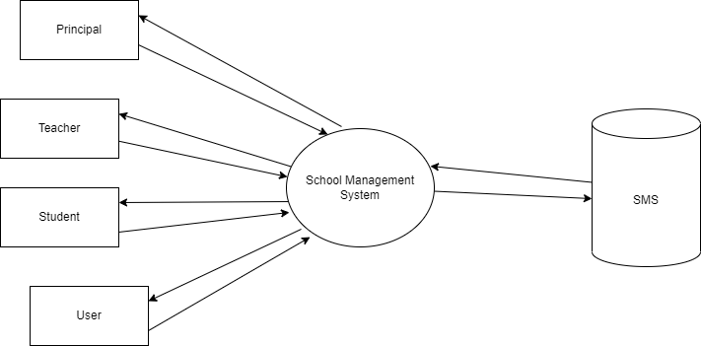

**Level 1.1**

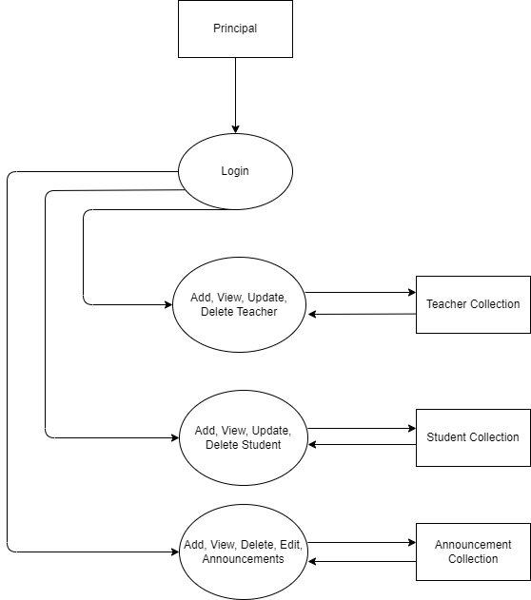

**Level 1.2**

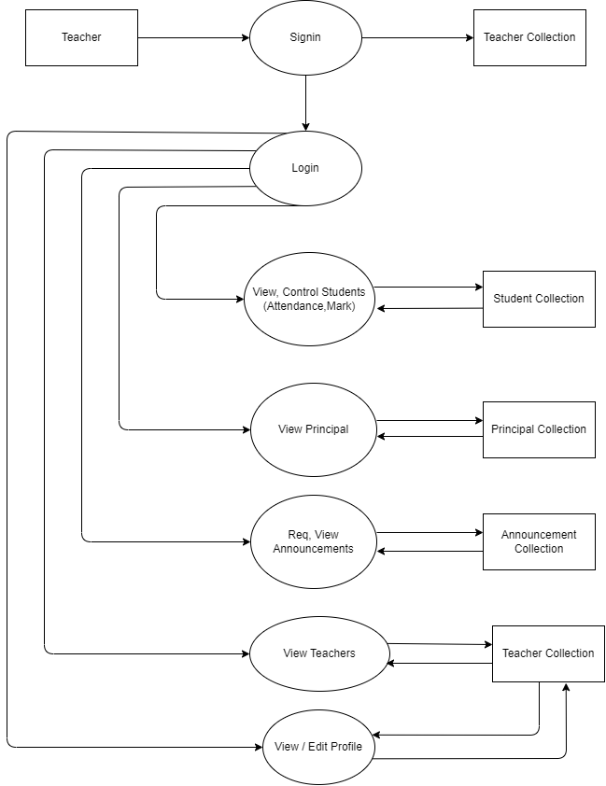

**Level 1.3**

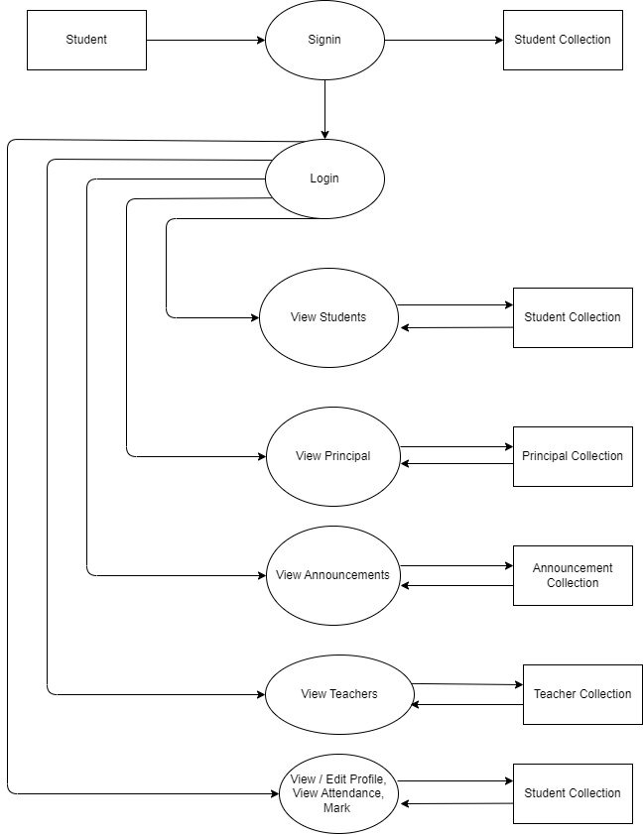

**Level 1.4**

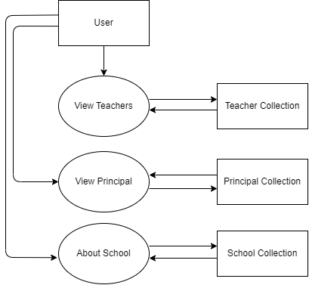

**11.2 Collection Structure**

**1. Principal**



**2. Teacher**



**3. Student**



**4. User**



1. **Announcements**



1. **Subjects**



1. **Announcement Request**



1. **Admission Request**



1. **Teacher Request**



**11.3 Sample Screen Format**

**User Index**

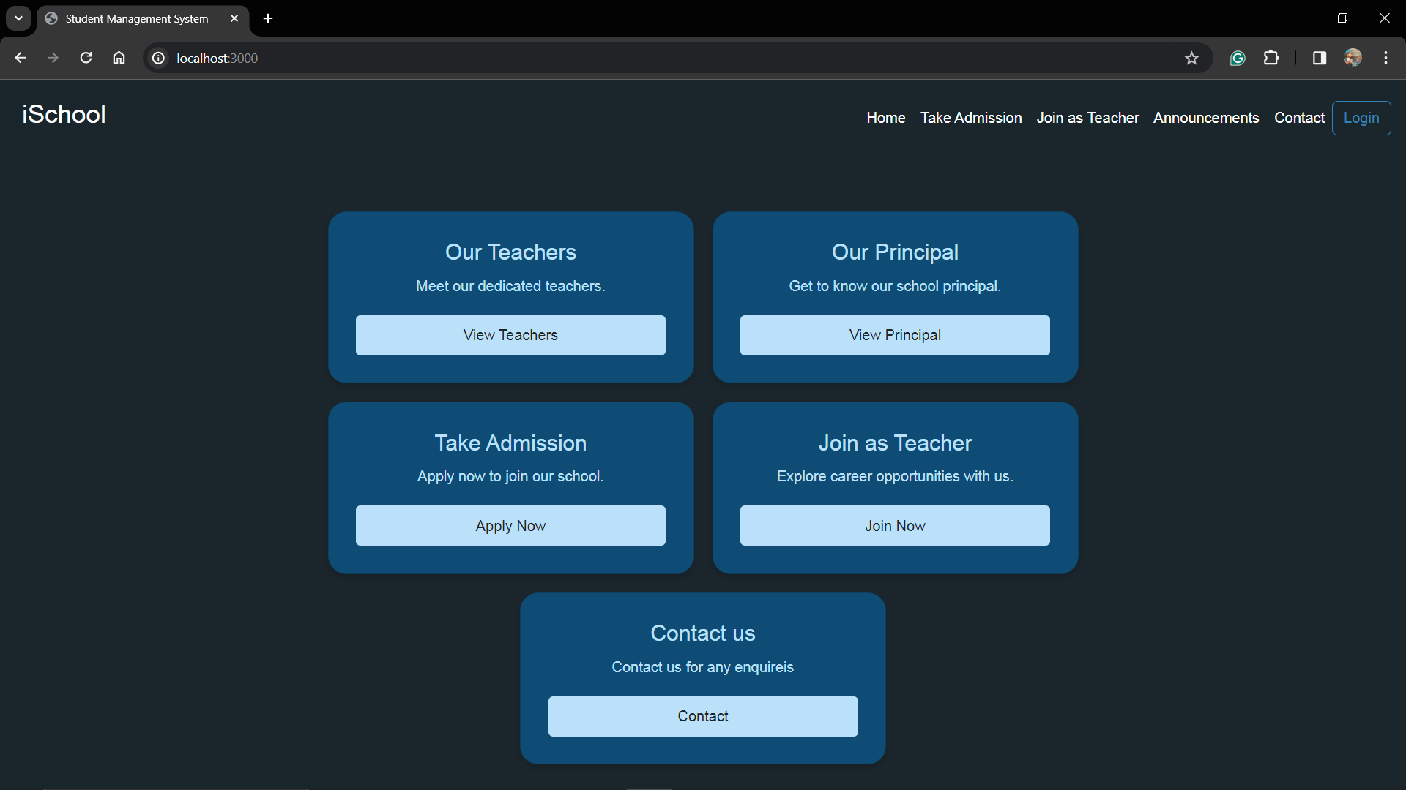

**Login Selection**

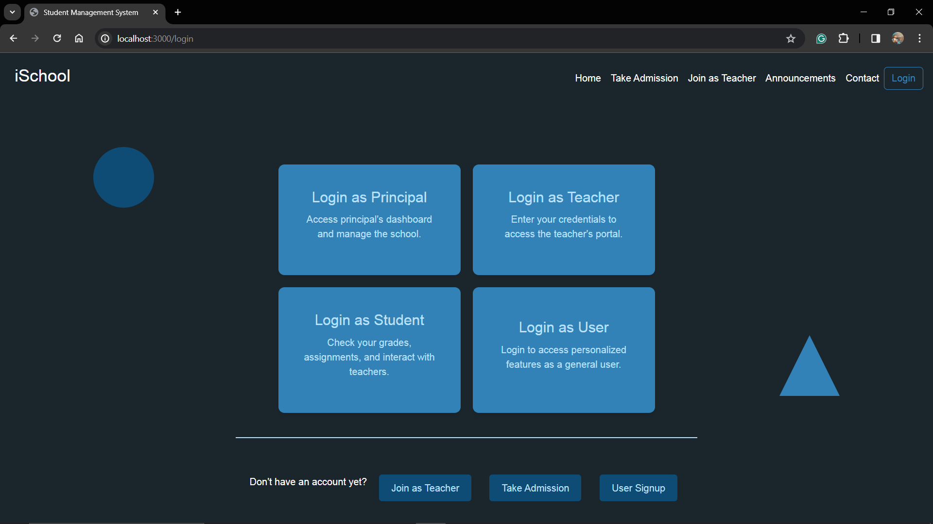

**Principal Login**

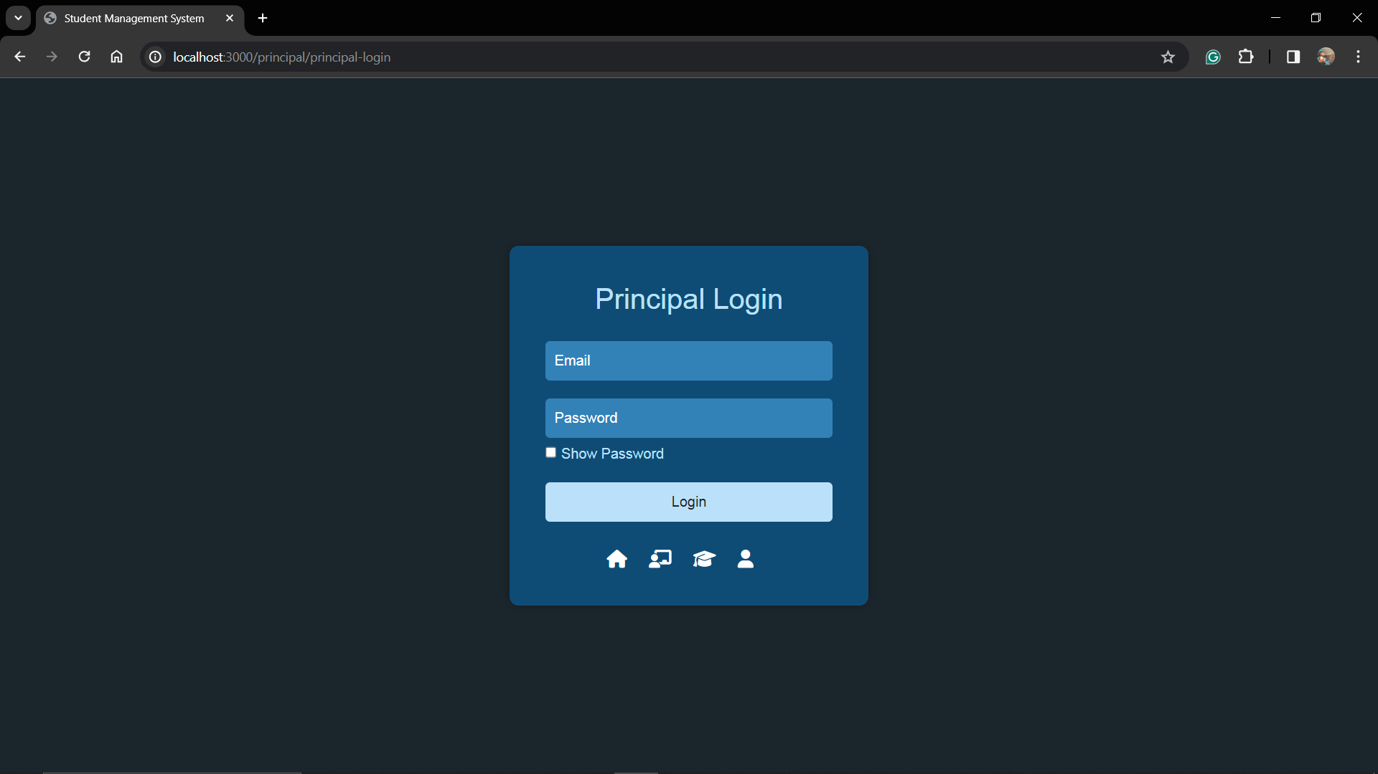

**Principal Dashboard**

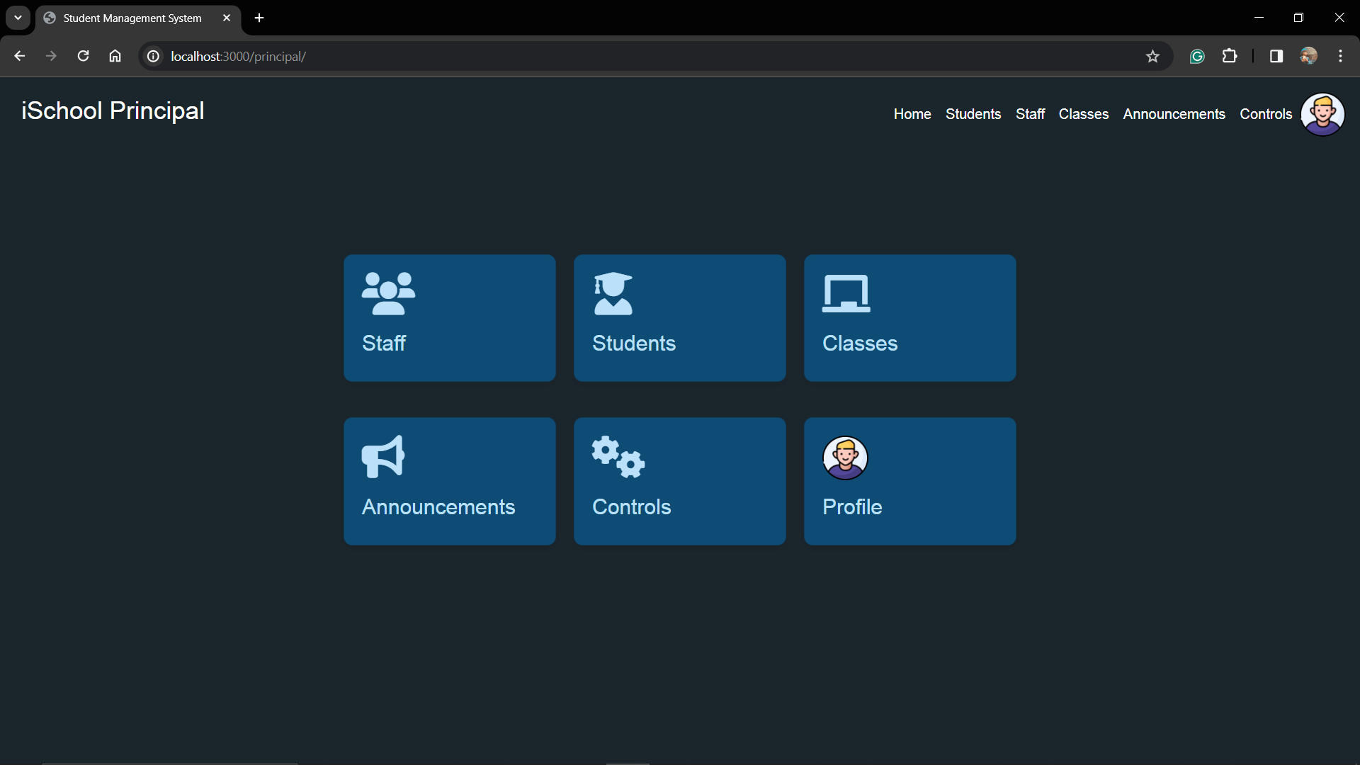

**All Students**

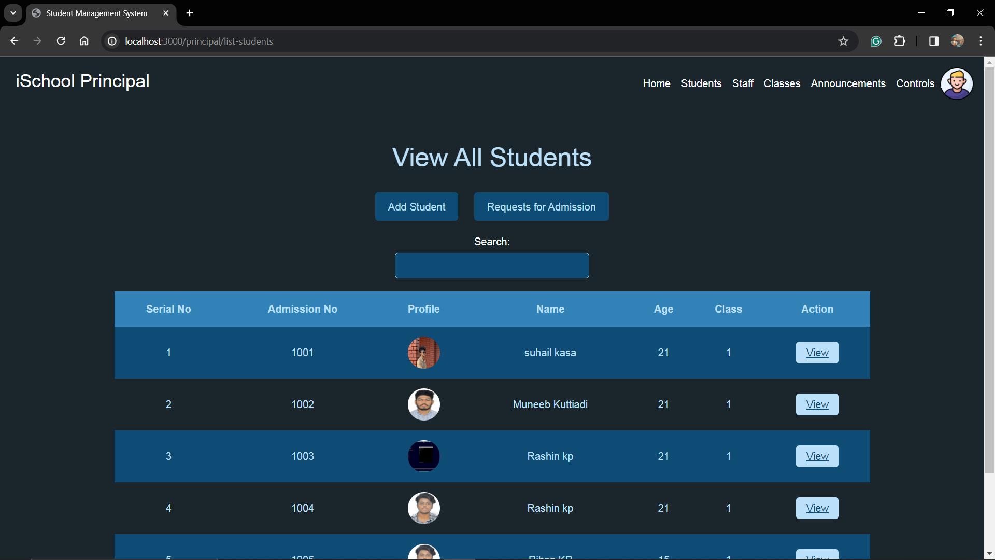

**All Teachers**

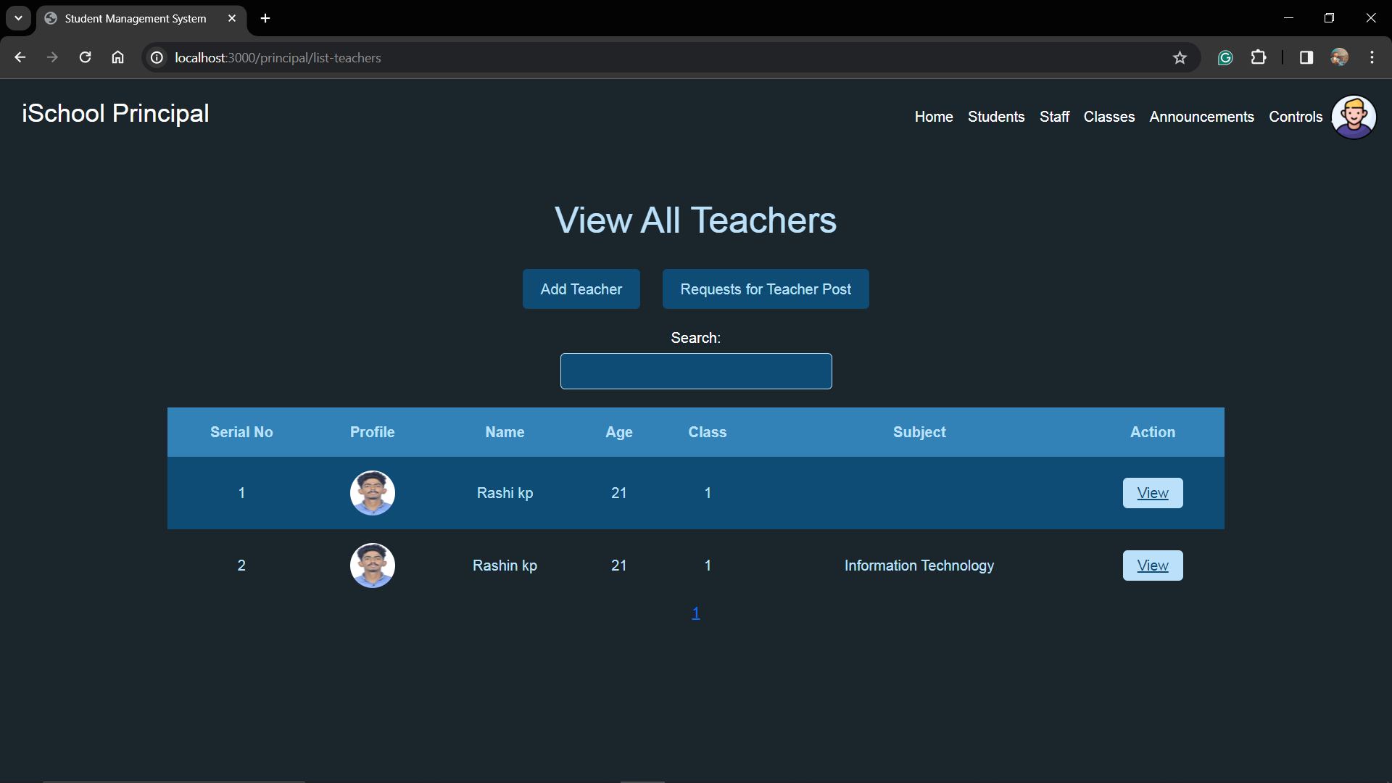

**Classes**

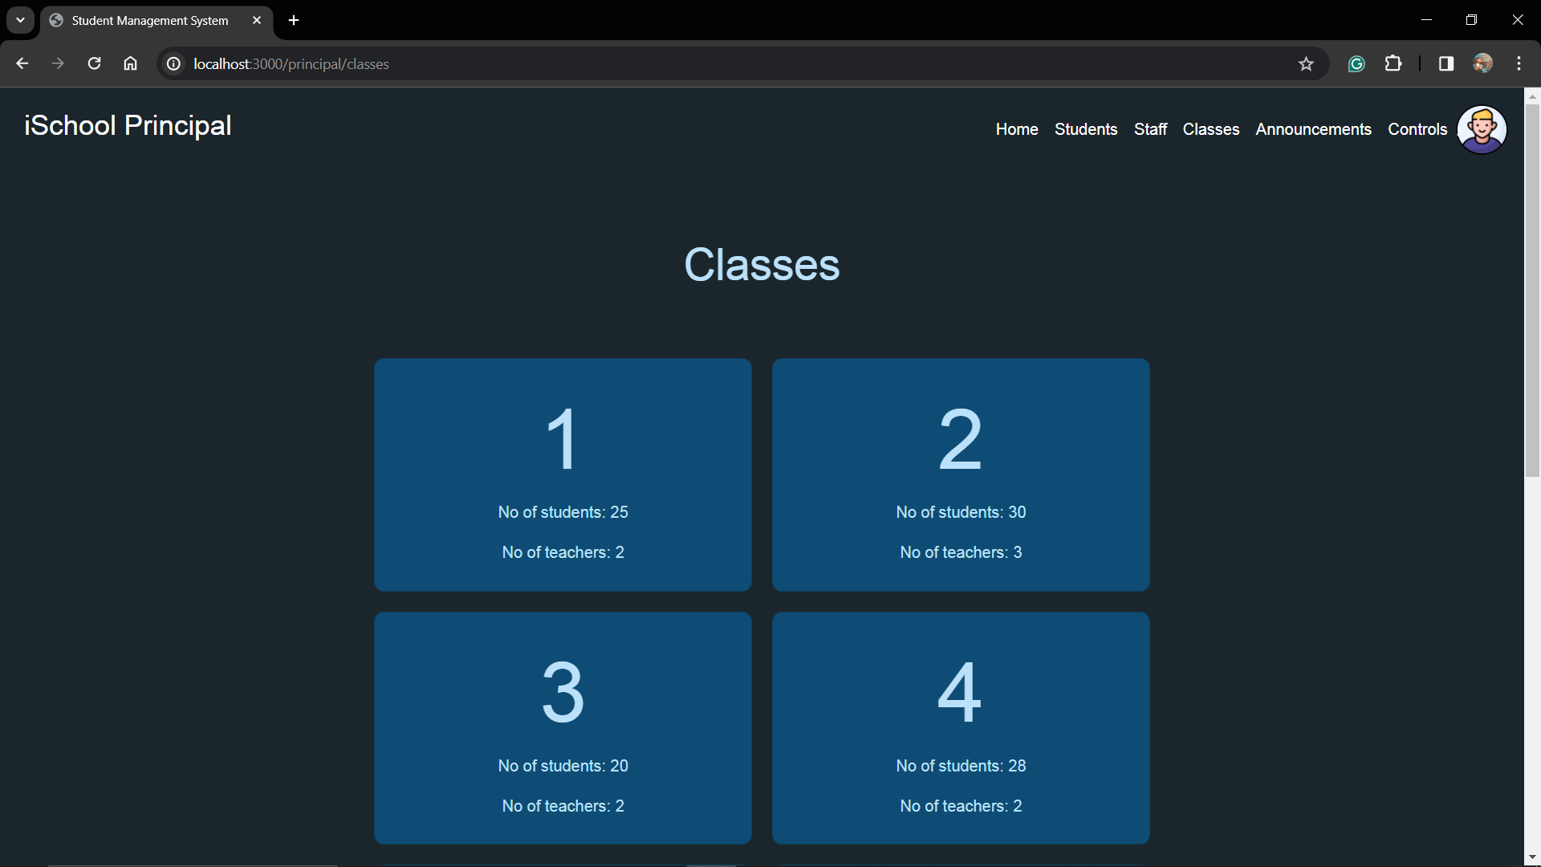

**Announcement (Principal)**

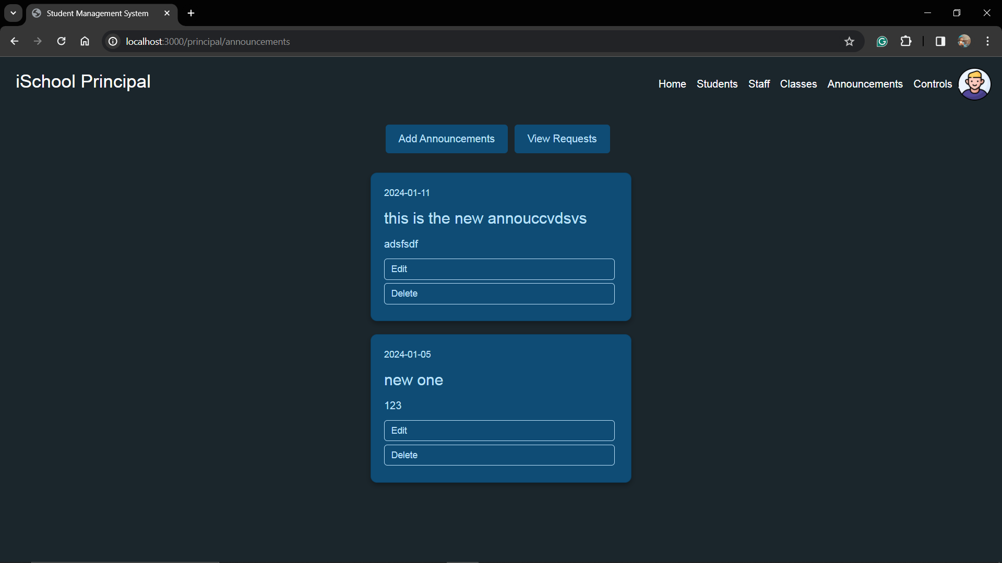

**Controls**

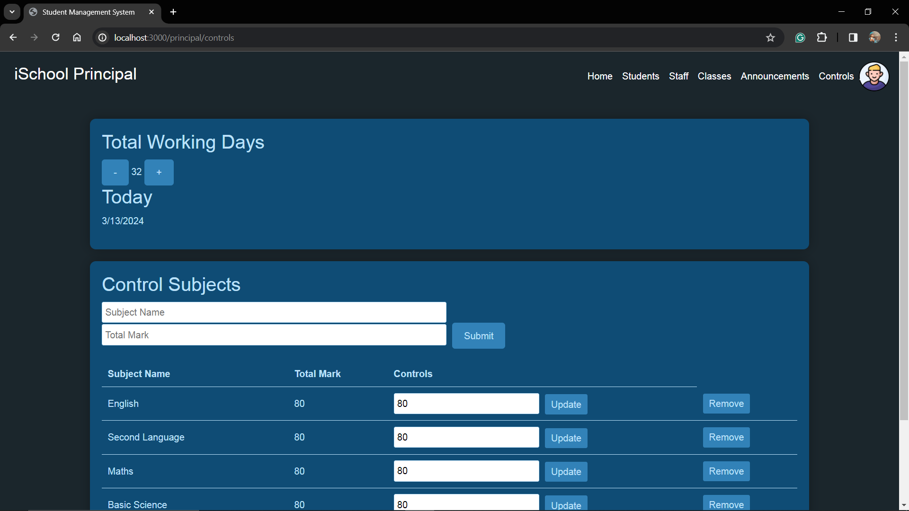

**Student Profile (Principal View)**

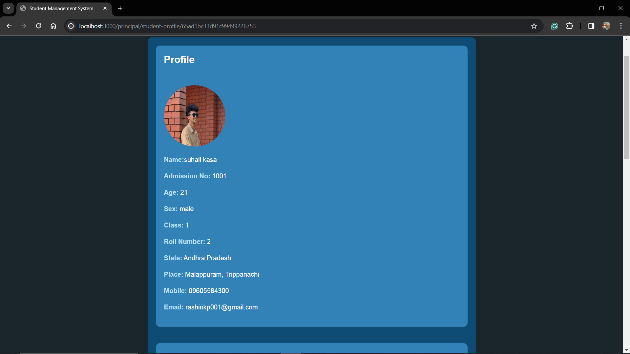

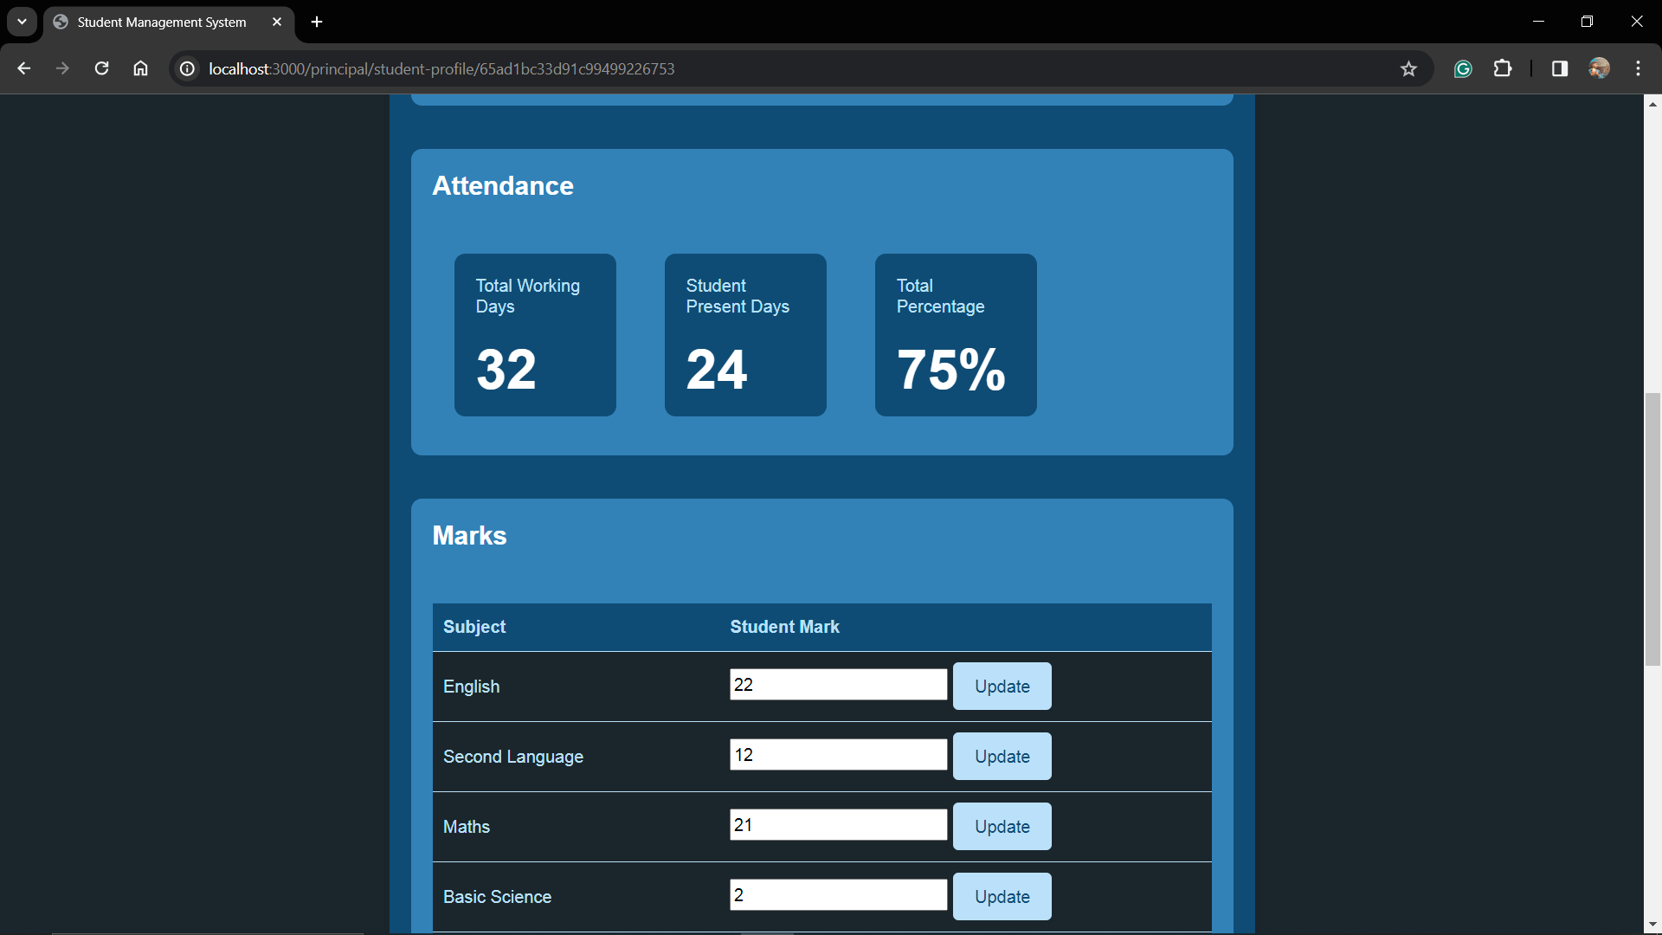

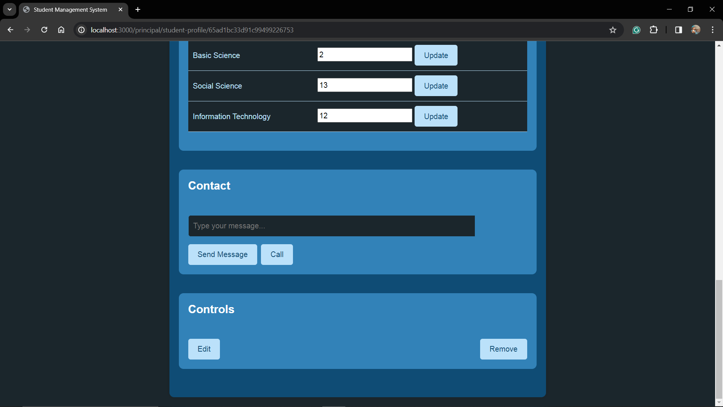

**Principal Profile**

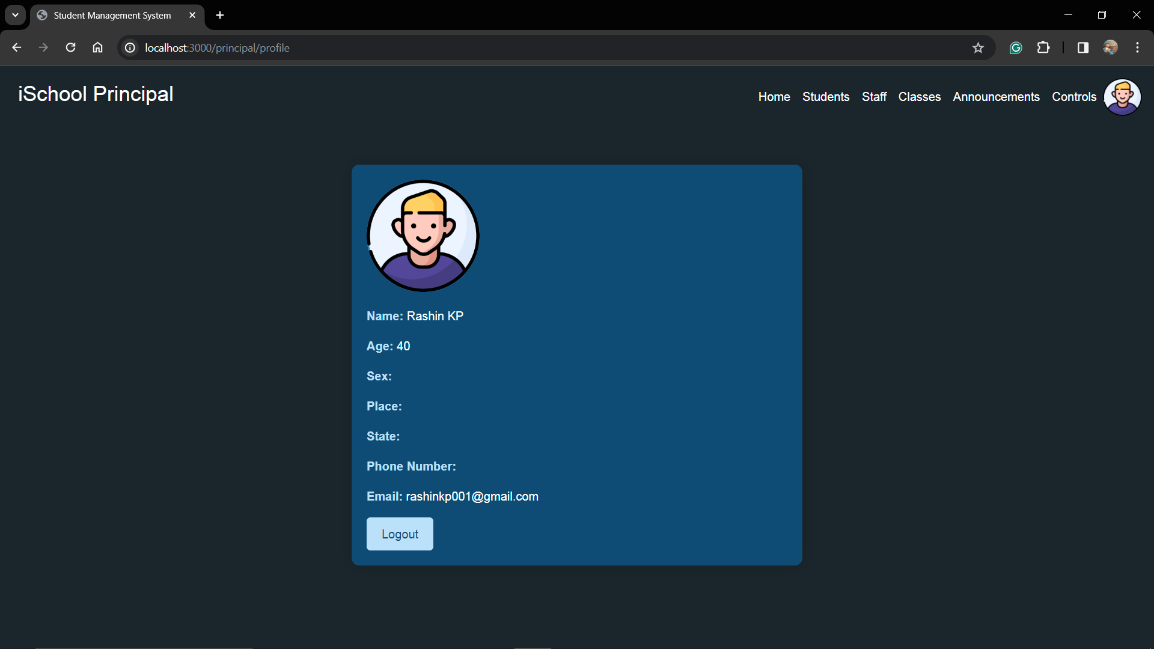

**Attendance**

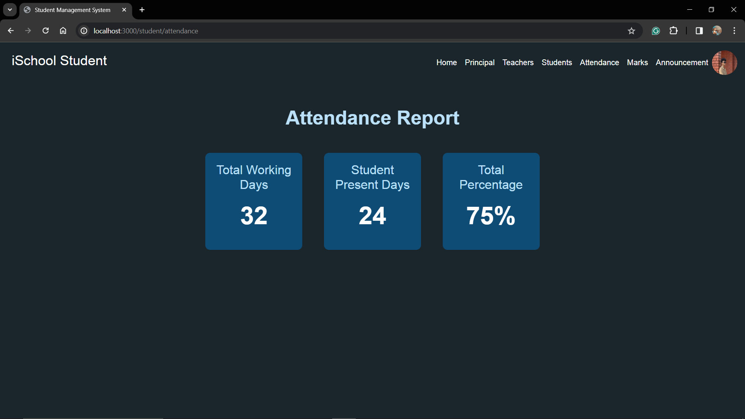

**Mark**

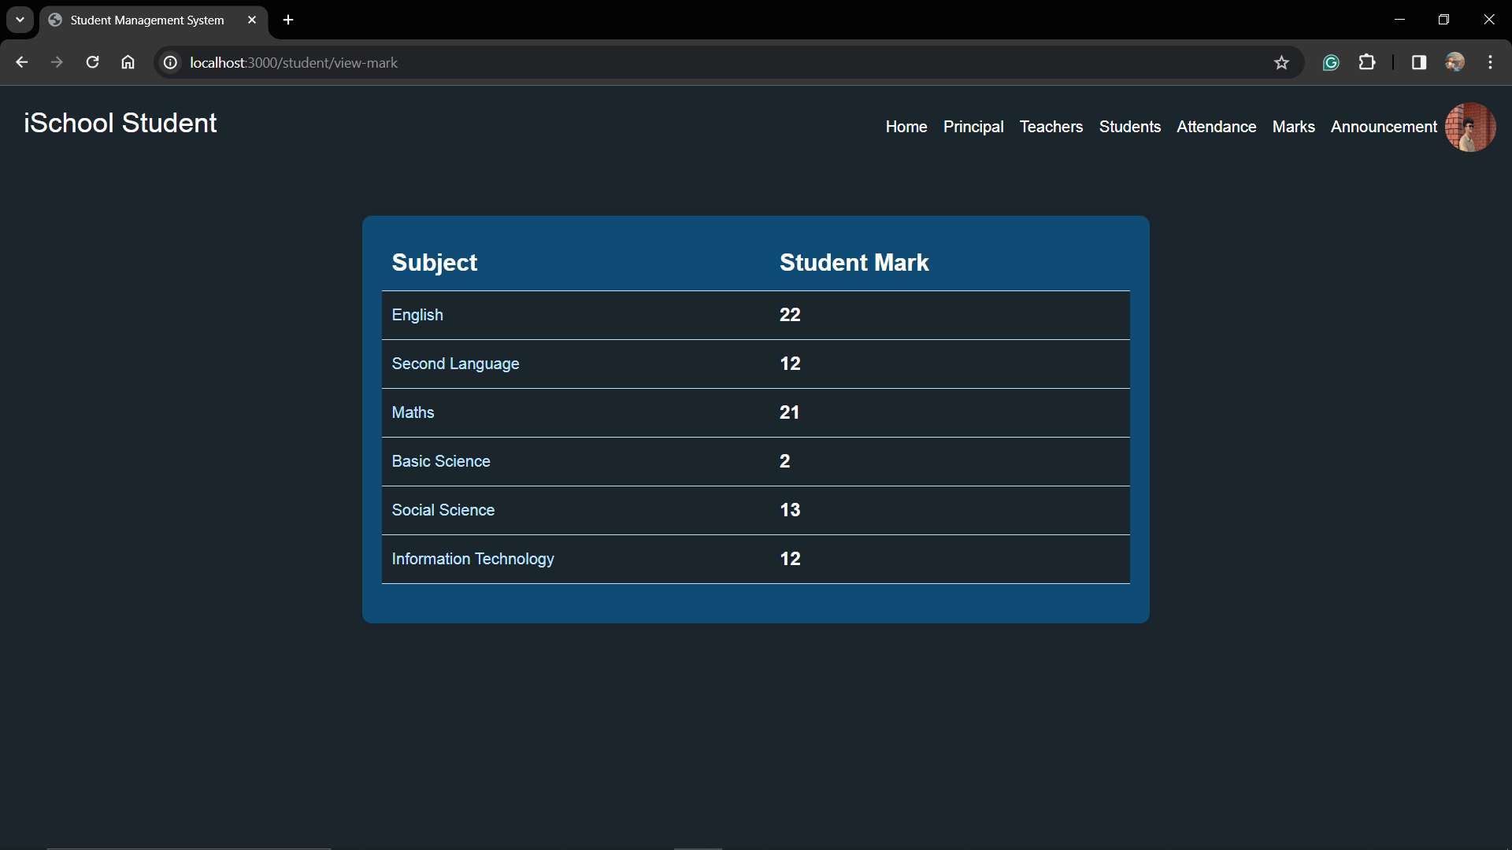

**Class control**

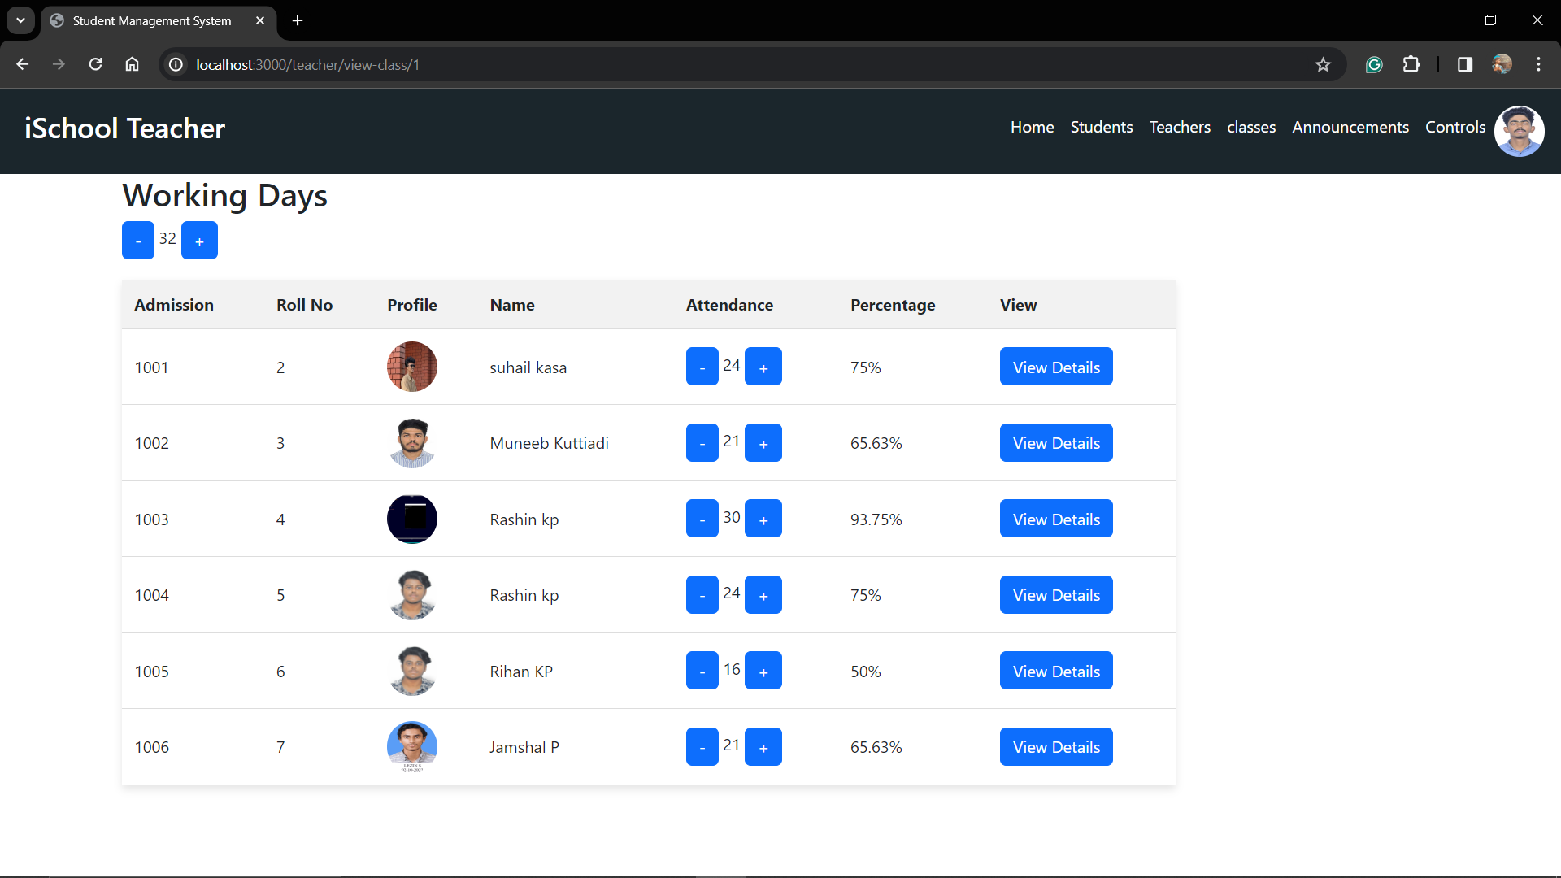

**Student Admission**

